**DAILY ONLINE ACTIVITIES SUMMARY**

|  |  |  |  |  |  |  |  |
| --- | --- | --- | --- | --- | --- | --- | --- |
| **Date:** | **3 July 2020** | | | | **Name:** | **Sinchana K N** | |
| **Sem & Sec** | **4th Sem B Sec** | | | | **USN:** | **4AL18CS083** | |
| **Online Test Summary** | | | | | | | |
| **Subject** | | **Not conducted** | | | | | |
| **Max. Marks** | | **0** | | **Score** | | **0** | |
| **Certification Course Summary** | | | | | | | |
| **Course** | **Data visualization using tableau** | | | | | | |
| **Certificate Provider** | | | **Great learners** | **Duration** | | | **11.5hrs** |
| **Coding Challenges** | | | | | | | |
| Problem Statement: Python Program to Check Armstrong Number | | | | | | | |
| **Status: executed** | | | | | | | |
| **Uploaded the report in Github** | | | | **Yes** | | | |
| **If yes Repository name** | | | | **https://github.com/acchu1234sinchana/Lockdown_coding1** | | | |
| **Uploaded the report in slack** | | | | **Yes** | | | |

Online Test Details: test was not conducted today.

Certification Course Details: today I have learnt about Importing Data Set In Tableau and Deriving insights : Number Vs Visuals

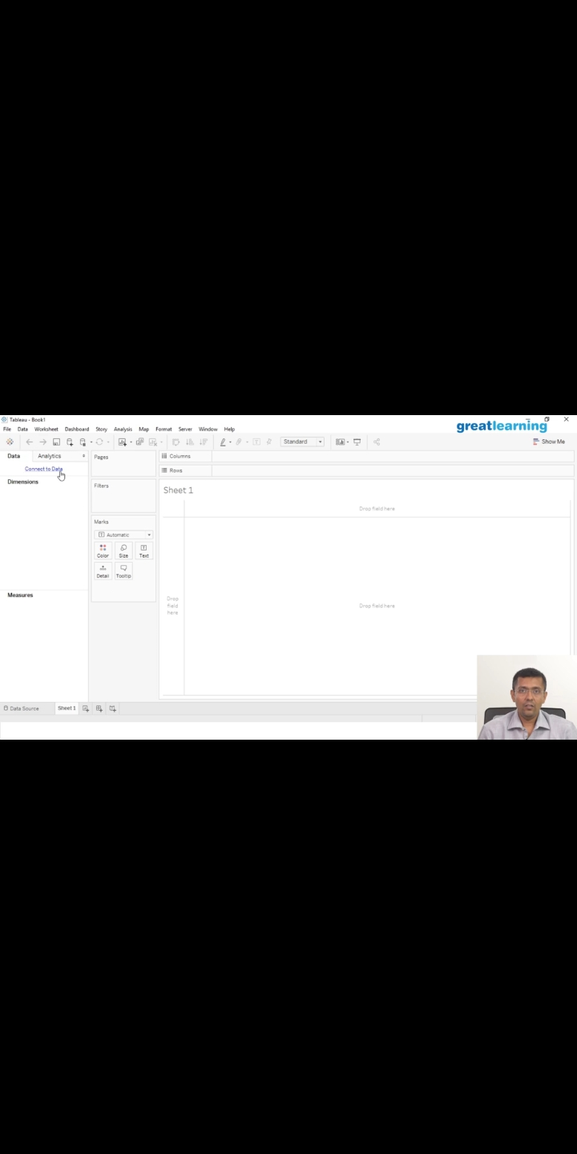

Coding Challenges Details: Every day we are given with new question of coding related to the language of java and c. it seems interesting how we imbibe our self in depth to understand the logic, break it and then code for it.

|  |
| --- |
| Today’s question was: Python Program to Check Armstrong NumberArmstrong number is a number that is equal to the sum of cubes of its digits. For example 0, 1, 153, 370, 371 and 407 are the Armstrong numbers. Let's try to understand why 153 is an Armstrong number. |

**Using the above given hint I have created the code.**

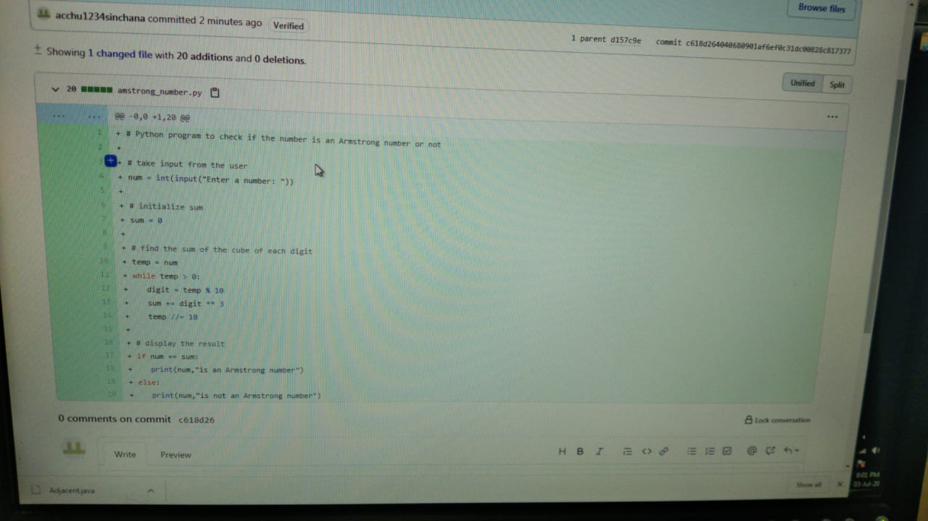

The above is the snapshot of github code that I have done.

Also a webinar was conducted on the topic c programming language.

Also the test was conducted for the same .

